PURCHASE ORDER

FOR

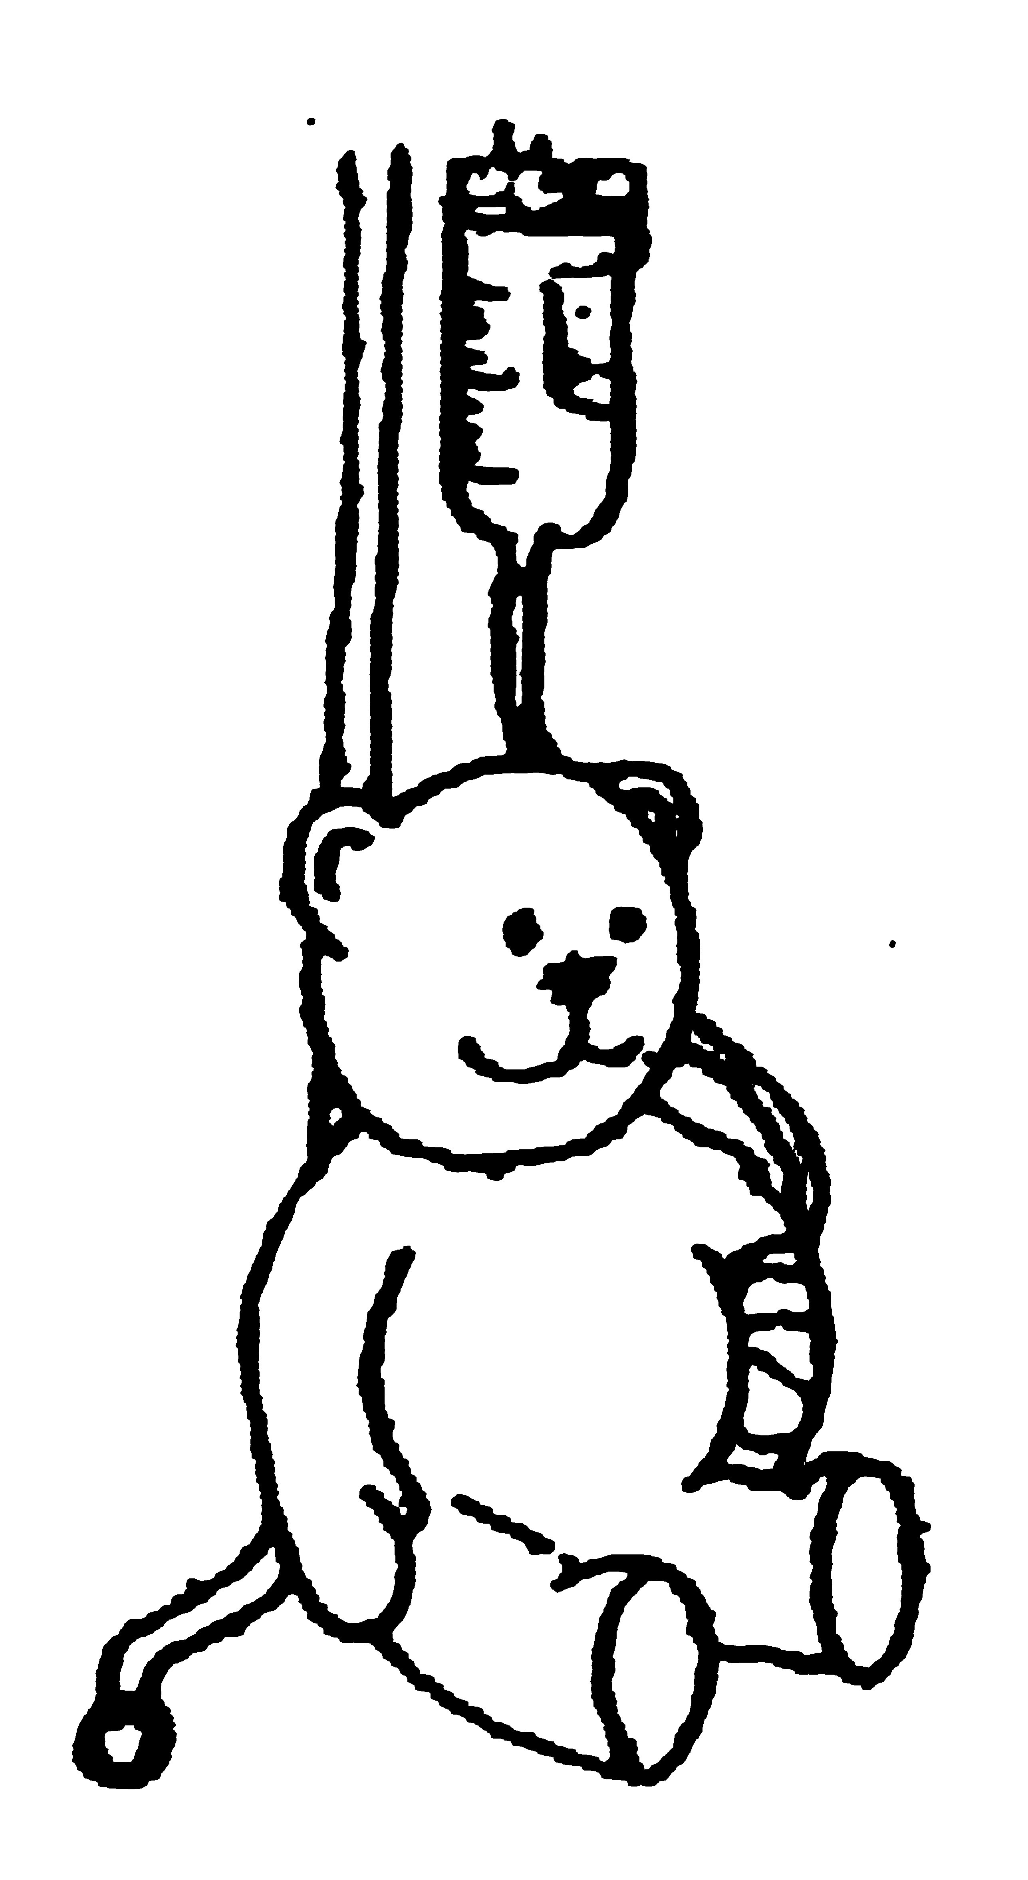
NAHPS SWEATSHIRTS AND POLO SHIRTS

The NAHPS Sweatshirt is available in navy blue and the Polo Shirts in navy, emerald and purple. All have a yellow teddy logo on the left breast surrounded by the words "National Association of Hospital Play Staff". All shirts are a mixture of cotton and polyester. Sizes shown are actual underarm measurements. Postage and packing are included.

Name
Delivery Address

Daytime Telephone No
Evening Telephone No
Date of Order

Sweatshirt Size  actual underarm measurements | SWEATSHIRT  Number required @£17.50 each | Polo Shirt Size  actual underarm measurements | POLO SHIRT  Number required @£14.00 each | COLOUR |  |  | TOTAL
 |  |  |  | Navy | Emerald | Purple | TOTAL
Small (40") |  | Small (42") |  |  |  |  | £
Medium (44") |  | Medium (44") |  |  |  |  | £
Large (46") |  | Large (46") |  |  |  |  | £
XLarge (48") |  | XLarge (48") |  |  |  |  | £
 |  |  |  | Donation to the charity |  |  | £
 |  |  |  | Cheque enclosed payable to NAHPS for |  |  | £

Please send order to:-
Sue Simpson NAHPS Publications Officer
50 Illtyd Avenue Llantwit Major Vale of Glamorgan CF61 1TH

