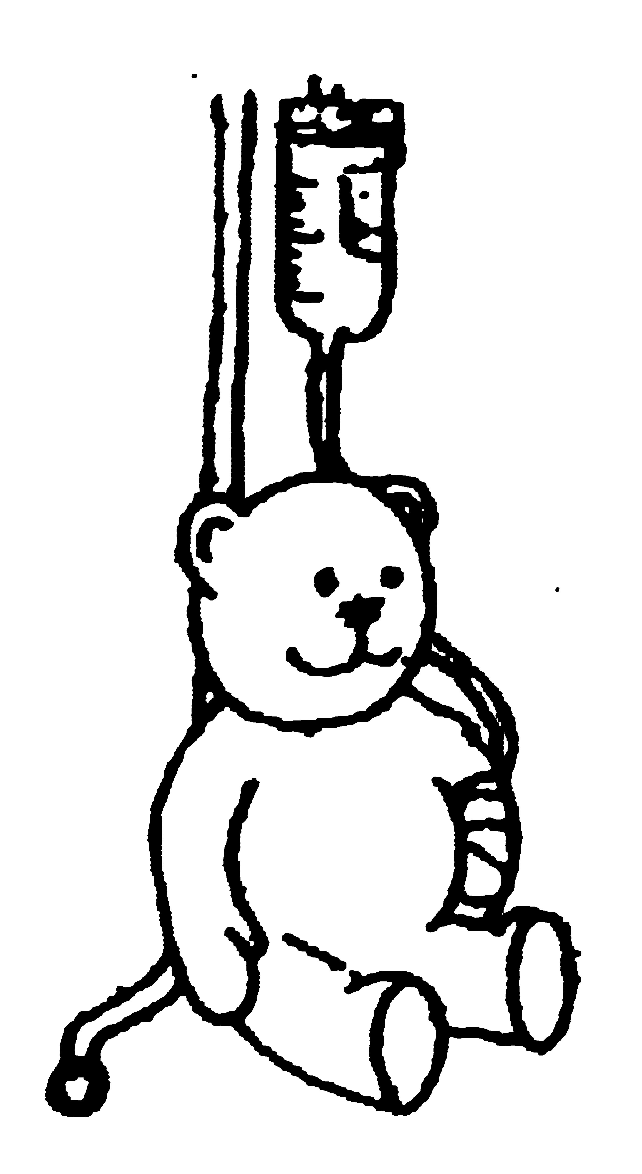

National Association of Hospital Play Staff (NAHPS)
Registered Charity No. 1042599

MEMBERSHIP FORM

Full Members: Play Staff with a qualification approved by NAHPS (HPSEB or equivalent). Full members receive our biannual professional Journal, newsletters, details of study days, publication lists and the opportunity for member's discounts to events and for NAHPS literature. They are also entitled to full voting rights at AGMs and EGMs and so have their say in decisions and how the profession is shaped.
Associate Members: Play Staff not holding the approved qualification and/or persons interested in furthering the work of NAHPS. Associate members receive our biannual professional Journal, newsletters, details of study days, publication lists and the opportunity for member's discounts to events and for NAHPS literature. We particularly value the support of Associate members in our work to improve the quality of play services for children in hospital.
Student Members: Students undertaking an HPSEB course. They receive eighteen months membership for the price of the usual twelve months. Student members receive our biannual professional Journal, newsletters, details of study days, publication lists and the opportunity for member's discounts to events and for NAHPS literature.
Corporate Members: Affiliated or interested organisations approved by the Association in General Meeting. Corporate members receive two copies of our biannual professional Journal, two copies of our newsletters, details of study days, publication lists and the opportunity for member's discounts to events and for NAHPS literature. Groups of play specialists are not eligible.
Retired Members: Retired Play Staff aged 55+will receive our biannual professional journal and newsletter


Application Form
Name
Home Address

Home Tel. No.
Place of Work
Address

Work Tel. No.
Title of Post
Full Member
- Year Training Completed
- College
Student Member
- Year training Commenced
- College
Corporate Member
- Name of Organisation
- Contact Person
Retired Member
- Date of Birth
Signature Date
Please tick fee enclosed
Full Member £25 ….. Associate Member £20 ….. Student Member £15 ….. Corporate Member £35 ….. Retired Member £15… ..
Donation to the work of the Charity £……
Please make your cheque or postal order payable to NAHPS

Please return to Sue Pallot 143 Gresham Rd, Staines, Middx, TW18 2AG

